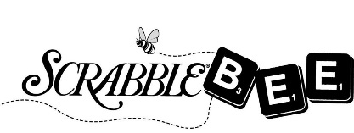
Each player will complete their own Pledge Form. Please ask your friends, family, neighbors & co-workers to pledge a donation toward the 2019 Scrabble Bee event. Top fund-raisers win prizes! Pledge online by going to http://www.literacycv.org and click on the ScrabbleBee banner.
Pledge Form
Your Name: _____________________________________________
Team Name: ____________________________________________
Company/Organization: ___________________________________

Bring this pledge form and your pledge money to the Scrabble Bee event Thursday, April 18th.
Questions? Call 715-834-0222

Name | Address | Phone | E-mail Address | Pledge Amount | Cash / Check / On-line

